QUOTATION FOR IP SERVICES: TRADEMARK | FY 2026–27
Quotation Number: 51/26-27
Date: 11/06/2026
To: Udupi Sanjeevini Mahila Kisan Producer Company
Stage-wise billing
A. Trademarks
Stage | Item | Govt fee | Prof fee | Total
Trademark Search | Search with result report  (optional)  (Basic trademark availability search is provided on a complimentary basis) | - | ₹10,000 | ₹10,000
Trademark Filing | Filing at TMO: startup / MSME/ individual | ₹4,500 | ₹7,500 | ₹12,000
Trademark Filing | Filing at TMO: startup /MSME / individual (with affidavit to claim earlier priority) | ₹4,500 | ₹15,000 | ₹19,500
Trademark Examination | Expedited examination | ₹20,000 | - | ₹20,000
Trademark Prosecution | Filing response to objection raised in Examination | - | ₹5,000 | ₹5,000
Trademark Prosecution | Attending objection hearing + filing written submission | - | ₹8,000- ₹10,000 | ₹8,000- ₹10,000

B. Miscellaneous Forms & Recordals
Govt fee at actuals + ₹5,000 prof fee per form
Applicable to any IP office form: assignment recordal, licensing recordal, change of name / address, renewal, restoration, and similar. Deed drafting (assignment, licensing) as per the Legal Services Fee Schedule.
C. General Notes
- All fees are exclusive of GST (18% applicable on professional fees), except copyright end-to-end fees which are all-in.
- Payment terms: 50% advance, 50% on completion; 100% advance for all government fees and out-of-pocket expenses.
- Stage-wise billing: each stage billed independently; if a stage does not occur, that fee is not charged.
- Standard turnaround: 24-48 working hours unless otherwise agreed
- Rush / urgency fee: 40-60% premium over applicable fee, confirmed in writing before commencement.
- Govt fees subject to revision by the respective IP office; any changes passed through at actuals.
- Every matter handled via systematic checklist and query document approach; all work, versions, and deliverables accessible through a dedicated client portal.
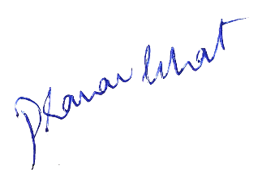


Adv. Pranav Bhat
Managing Partner,
Lextria Research
pranavbhat@lextria.in
+91-9035685434

